C4- S4-PRACTICE

# What you will know:

**Combining data** from multiple tables using MULTIPLE **JOINS**

1. This exercise is based on given ONLINE database:

<https://www.w3schools.com/sql/trysql.asp?filename=trysql_select_where>

* Test your queries on the online editor
* Copy / paste your answer for each question on this document

**Q1**: Write the query to display for each order ID, the name of the customer

As example:

|  |  |
| --- | --- |
| OrderID | CustomerName |
| 10248 | Wilman Kala |
| 10249 | Tradição Hipermercados |
| 10250 | Hanari Carnes |
| 10251 | Victuailles en stock |
| 10252 | Suprêmes délices |

Your answer:

SELECT Orders.OrderID, Customers.CustomerName

FROM Orders

INNER JOIN Customers ON Orders.CustomerID=Customers.CustomerID;

**Q2:** Display the products (no duplicate) the customer "Familia Arquibaldo" has bought.

Your answer:

SELECT DISTINCT Customers.CustomerName, Count( orderdetails.OrderDetailID) from OrderDetails

inner join Products on orderdetails.productid = products.productid

inner join Orders on orderdetails.orderid = orders.orderid

inner join customers on orders.customerid = customers.customerid

WHERE products.productName = "Tofu";

**Q3:** Display the 10 products names which are the MOST SOLD products

Your answer:

SELECT COUNT (productname) FROM orderdetails

INNER JOIN products on orderdetails.productid = products.productid

GROUP BY productname ORDER BY (COUNT (productname)) DESC LIMIT 10;

**Q4:** Display all products shipped by "Speeding Express"

Your answer:

SELECT products.productname FROM orderdetails

INNER JOIN products ON orderdetails.productid = products.productid

INNER join orders ON orderdetails.orderid = orders.orderid

INNER JOIN shippers ON orders.shipperid = shippers.shipperid WHERE shippers.shippername = 'Speedy Express';

Q5: Display all customers and suppliers who belong to the same country.

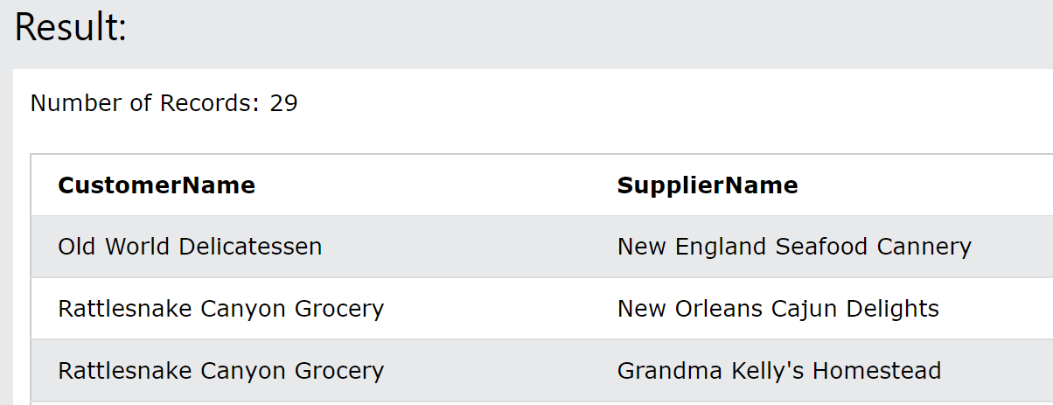

Your answer:

SELECT customers.customername, suppliers.suppliername FROM orderdetails

INNER JOIN products ON orderdetails.productid = products.productid

INNER join orders ON orderdetails.orderid = orders.orderid

INNER JOIN customers on orders.customerid = customers.customerid

INNER JOIN suppliers on products.supplierid = suppliers.supplierid

WHERE customers.country = suppliers.country;

1. Mommy Hopital want to store information about :

* **Doctors** that are described by their first name, last name , **salary** , **phone** and **email address.**
* **Patients** that are described by their first name, last name,**phone, address , job and**  Sickness **description.**



Here is some more information on how works the company:

* a patient can make many appointments with many doctors.

**Q1** – What is the relation between Doctors and Patients? why?

many to many

* a patient can make many appointments with many doctors.
* A doctor meets many patients.

**Q2** - Do you create an association table? why?

● Yes, I need an association table for storing appointments dates of each patient.

**Q3 -** Design the ERD of Mommy Hospital database

|  |  |  |
| --- | --- | --- |
| **Doctors_Patients_Appointment** | | |
| FK  FK | Doctor_ID  Patient_ID  Appiontment_date | Int  Int |

|  |  |  |
| --- | --- | --- |
| **Patients** | | |
| Pk | Patient_ID  Firstname  Lastname  Phone  Address  Job  Sickness description | Int  Varchar (100)  Varchar (100)  Int  Varchar (100)  Int  Varchar (200) |

|  |  |  |
| --- | --- | --- |
| **Doctors** | | |
| Pk | Doctor_ID  Firstname  Lastname  Salary  Phone  Email | Int  Varchar (100)  Varchar (100)  Int  Int  Varchar (100) |

**Q4 –** Implement this database in MySQL

* Create database named Mommyhospital

[CREATE](http://localhost:8080/phpmyadmin/url.php?url=https://dev.mysql.com/doc/refman/8.0/en/create-database.html) [DATABASE](http://localhost:8080/phpmyadmin/url.php?url=https://dev.mysql.com/doc/refman/8.0/en/create-database.html) [if](http://localhost:8080/phpmyadmin/url.php?url=https://dev.mysql.com/doc/refman/8.0/en/control-flow-functions.html#function_if) [not](http://localhost:8080/phpmyadmin/url.php?url=https://dev.mysql.com/doc/refman/8.0/en/logical-operators.html#operator_not) EXISTS mommyhospital;

* Create doctor table

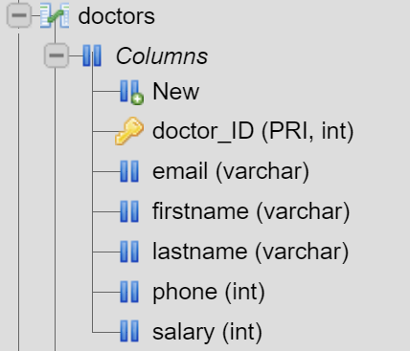CREATE TABLE if NOT EXISTS doctors (doctor_ID int AUTO_INCREMENT PRIMARY KEY, firstname varchar (100), lastname varchar(100), salary int,

phone int, email varchar (100));

* Create patient table

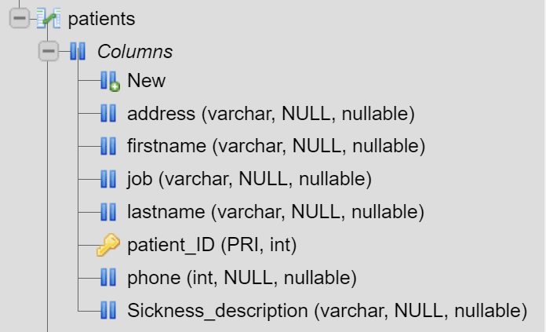[CREATE](http://localhost:8080/phpmyadmin/url.php?url=https://dev.mysql.com/doc/refman/8.0/en/create-table.html) [table](http://localhost:8080/phpmyadmin/url.php?url=https://dev.mysql.com/doc/refman/8.0/en/create-table.html) [IF](http://localhost:8080/phpmyadmin/url.php?url=https://dev.mysql.com/doc/refman/8.0/en/control-flow-functions.html#function_if) [NOT](http://localhost:8080/phpmyadmin/url.php?url=https://dev.mysql.com/doc/refman/8.0/en/logical-operators.html#operator_not) EXISTS patients (patient_ID [int](http://localhost:8080/phpmyadmin/url.php?url=https://dev.mysql.com/doc/refman/8.0/en/numeric-types.html) AUTO_INCREMENT PRIMARY key, firstname [varchar](http://localhost:8080/phpmyadmin/url.php?url=https://dev.mysql.com/doc/refman/8.0/en/string-types.html) (100),lastname [varchar](http://localhost:8080/phpmyadmin/url.php?url=https://dev.mysql.com/doc/refman/8.0/en/string-types.html) (100), phone [int](http://localhost:8080/phpmyadmin/url.php?url=https://dev.mysql.com/doc/refman/8.0/en/numeric-types.html), address [varchar](http://localhost:8080/phpmyadmin/url.php?url=https://dev.mysql.com/doc/refman/8.0/en/string-types.html) (100), job [varchar](http://localhost:8080/phpmyadmin/url.php?url=https://dev.mysql.com/doc/refman/8.0/en/string-types.html) (100), Sickness_description [varchar](http://localhost:8080/phpmyadmin/url.php?url=https://dev.mysql.com/doc/refman/8.0/en/string-types.html) (200)

* Create Doctors_Patients_Appointment table

CREATE TABLE IF NOT EXISTS Doctors_Patients_Appointment(doctor_id int, patient_id int,appointment_date datetime, FOREIGN KEY (doctor_id) REFERENCES doctors(doctor_id), FOREIGN KEY (patient_id) REFERENCES patients(patient_id));

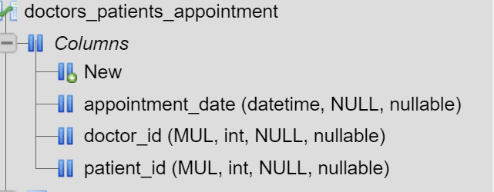

**Q5 –** Insert the following in the right table

1. Patient Jonh Mongly plan to meet doctor on 20 August , 2021 with doctor Smit at 8am.

2. On the same day, Jonh Mongly want to meet doctor Sundra at 10am.

3. Today Makar’s son is not well. They are going to meet doctor Bun Long as soon as possible.

4. Patient Seyha met doctor Bun Long last year on 10 June 2020.

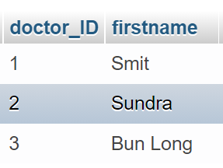

Inserting Doctor

Insert into doctors (firstname)

values (“Smit”)

(“Sundra”)

(“Bun Long”);

Inserting patients

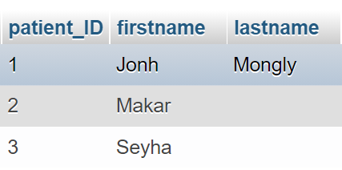INSERT into patients (firstname, lastname)

VALUES ('Jonh','Mongly'),

('Makar',’’),

('Seyha',’’);

Insert in to appointment table

[INSERT](http://localhost:8080/phpmyadmin/url.php?url=https://dev.mysql.com/doc/refman/8.0/en/insert.html) INTO doctors_patients_appointment (doctor_id,patient_id,appointment_date)

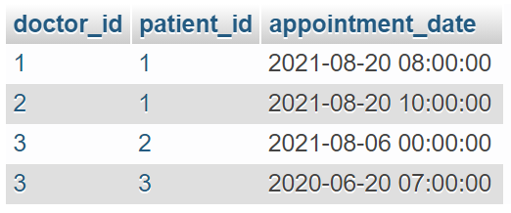[VALUES](http://localhost:8080/phpmyadmin/url.php?url=https://dev.mysql.com/doc/refman/8.0/en/miscellaneous-functions.html#function_values)  (1,1,'2021-08-20 08:00:00'),

 (2,1,'2021-08-20 10:00:00'),

 (3,2,[CURRENT_DATE](http://localhost:8080/phpmyadmin/url.php?url=https://dev.mysql.com/doc/refman/8.0/en/date-and-time-functions.html#function_current_date)()),

(3,3,'2020-06-20 07:00:00');